**NODE JS**

Difference between Javascript and node js

|  |  |
| --- | --- |
| Javascript | Node js |
| 1.Javascript is browser based language | 1.Node js can to standalone application |

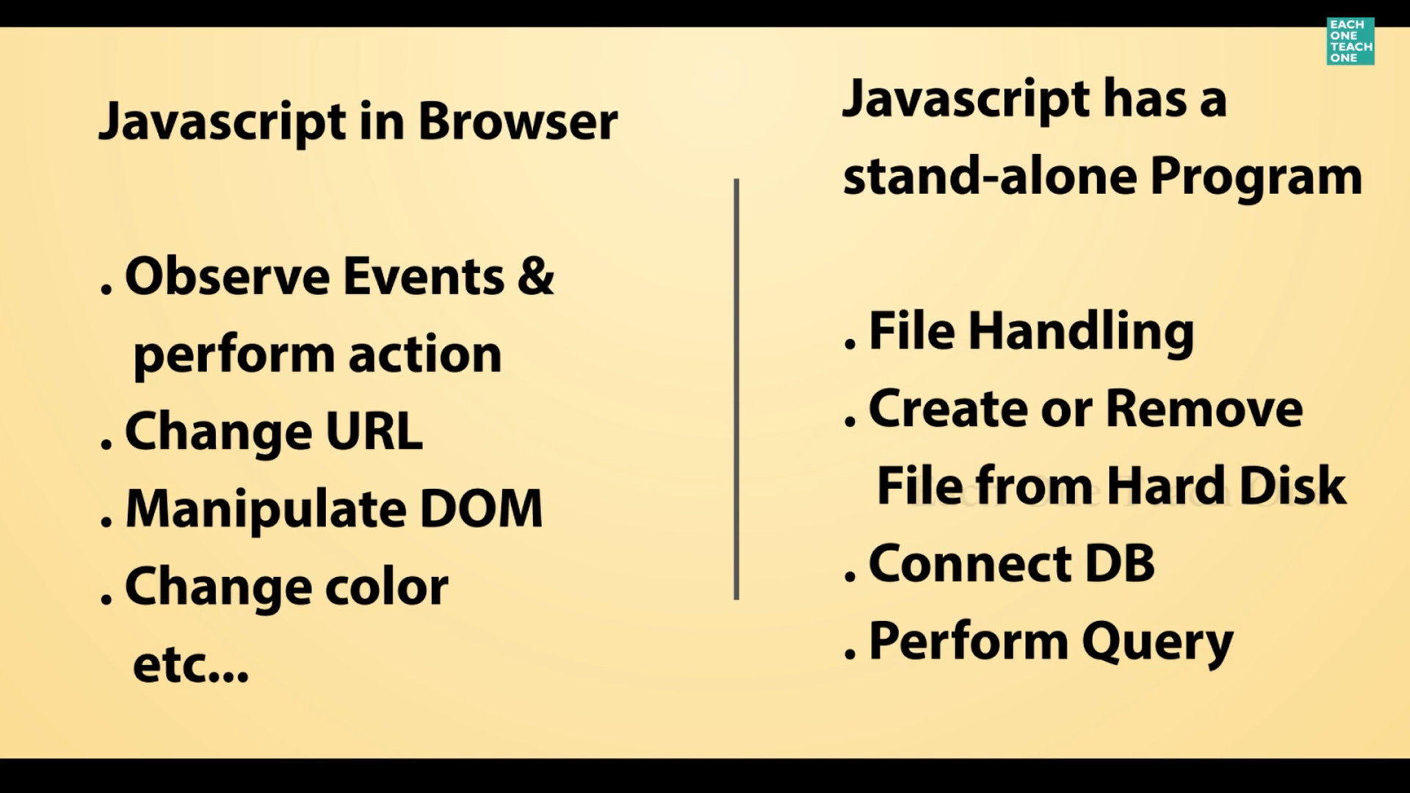

* Compiler:
* V8 engine--🡪written in C++ language
* Google chrome using v8 engine for compiling

Using Terminology:

|  |  |
| --- | --- |
| Javascript | Node js |
| Window🡪control overall window | Global |
| Document-> control pages | process |

Why uses node.js:

* Non blocking I/O
* Multiple job handle at the same time
* NPM(Node Package Management)
* It’s a library contain package
* According to our requirement we just import the package from open source and implement in our project

Tutorial sub topic:

1. Require Function

1.Require Function:

* Reduce the number of lines of code

How:

* Splitting the functionality wise and kept in different file.
* Call the functionality by through **require** keyword.
* Call the predefined packages(eg: file system,OS functionality) by through **require** keyword.
* Call the third party package from open source(eg:from npm open source where all developer put the code).

Eg :

1. Call the predefined packages(eg: file system,OS functionality) by through **require** keyword.

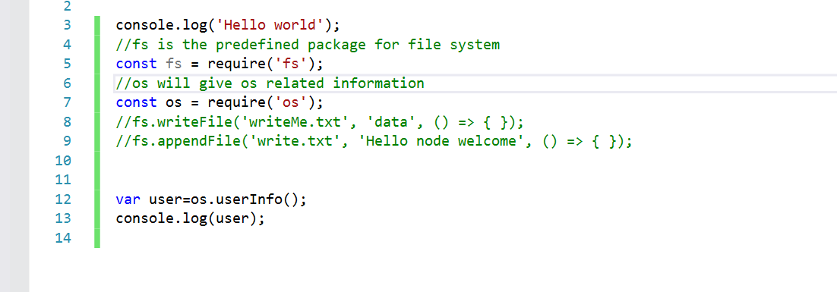

2. Reduce the number of lines of code

How:

* Splitting the functionality wise and kept in different file.
* Call the functionality by through **require** keyword.

o/p:

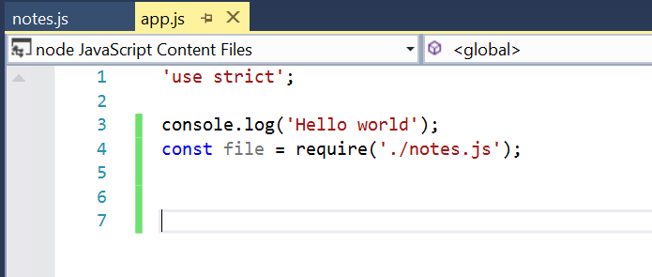

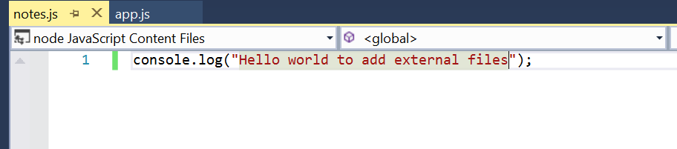

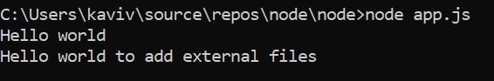

* **Module in Node js:**
* Inside module🡪 object and key value pair

**Eg:**

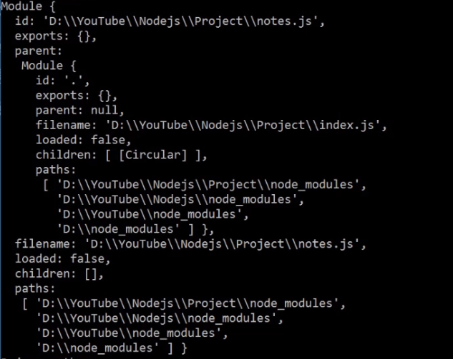

**Now we are using export value:**

* To send variable or function return value from notes.js to index.js.

**Eg:**

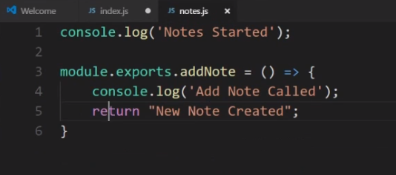

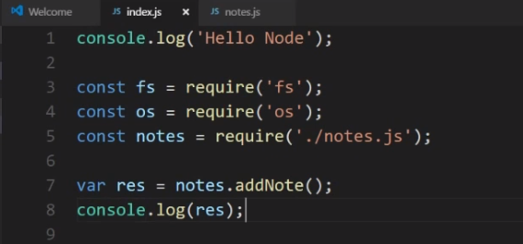

**o/p:**

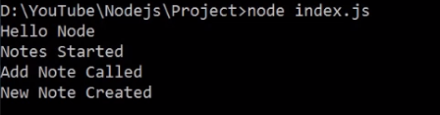

1. Call the third party package from open source

E-Commerce Project:

* Flora website:

Steps1:

Description:

To initialise the project

Command:

npm init

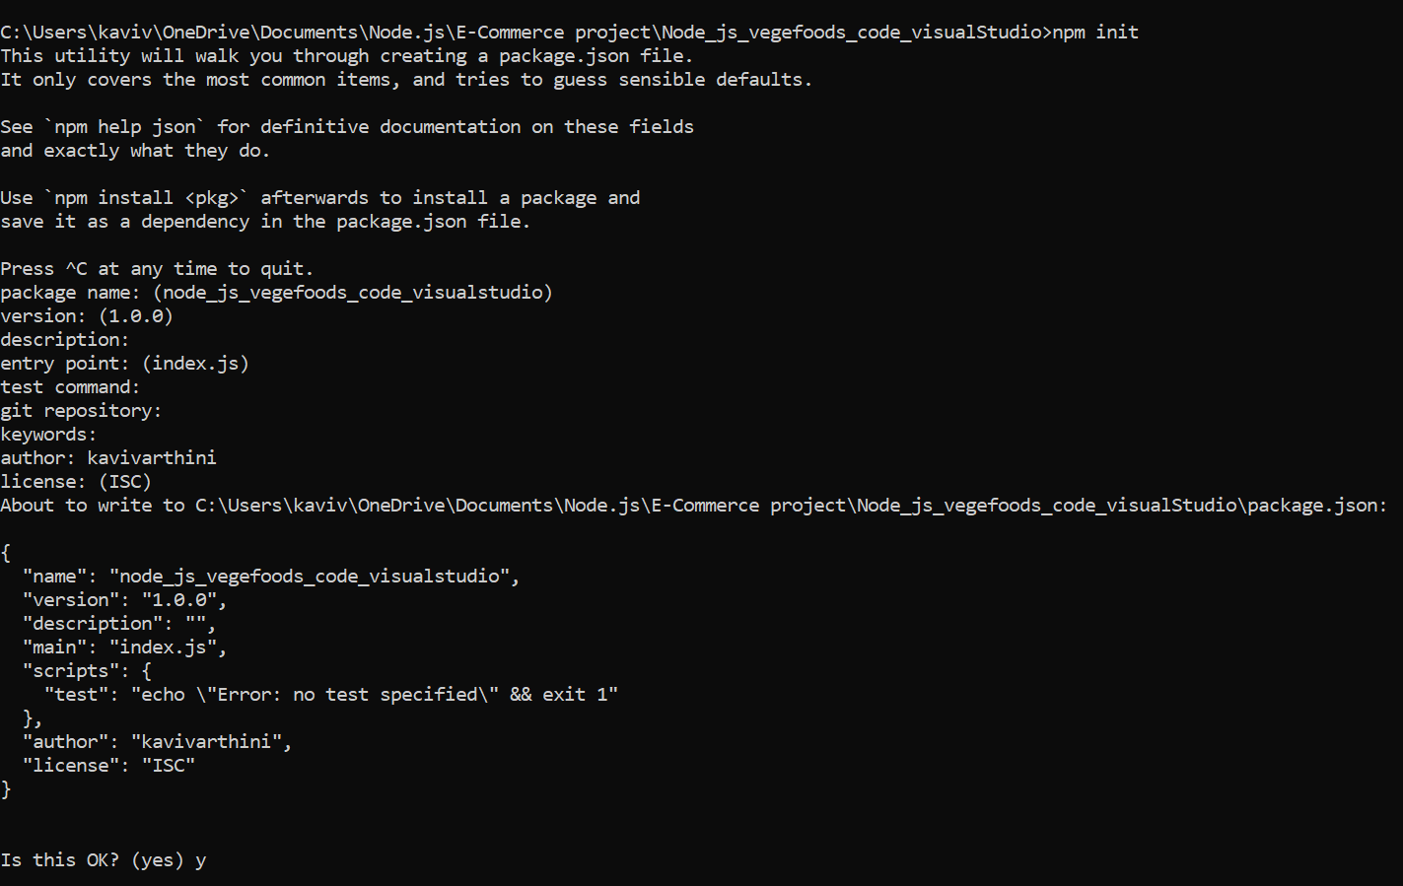

O/P: package.json will be automatically placed inside the project

|  |
| --- |
| **Notes: install-🡪require-🡪config** |

Steps2:

Description:

* + - * Express.js used to see front page(view part)

Command:

npm install express –save

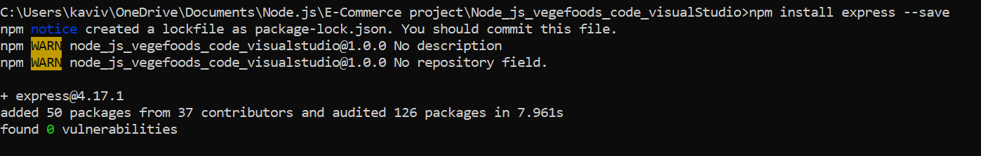

O/P:

Can able to see the page